STUDENT ACTIVITIES for URBAN PLACES

Created by Lorraine Chaffer, Editor Geography Bulletin

The Geography Bulletin 2019 Edition 2 (Volume 51 No 2)
https://www.gtansw.org.au/members/login.php

This document has been provided in both PDF and Word formats to allow teachers to add or delete elements as appropriate to their students.

Login to your account to access the GTA Bulletins and individual articles for printing where required.

Instructions are provided with each activity.

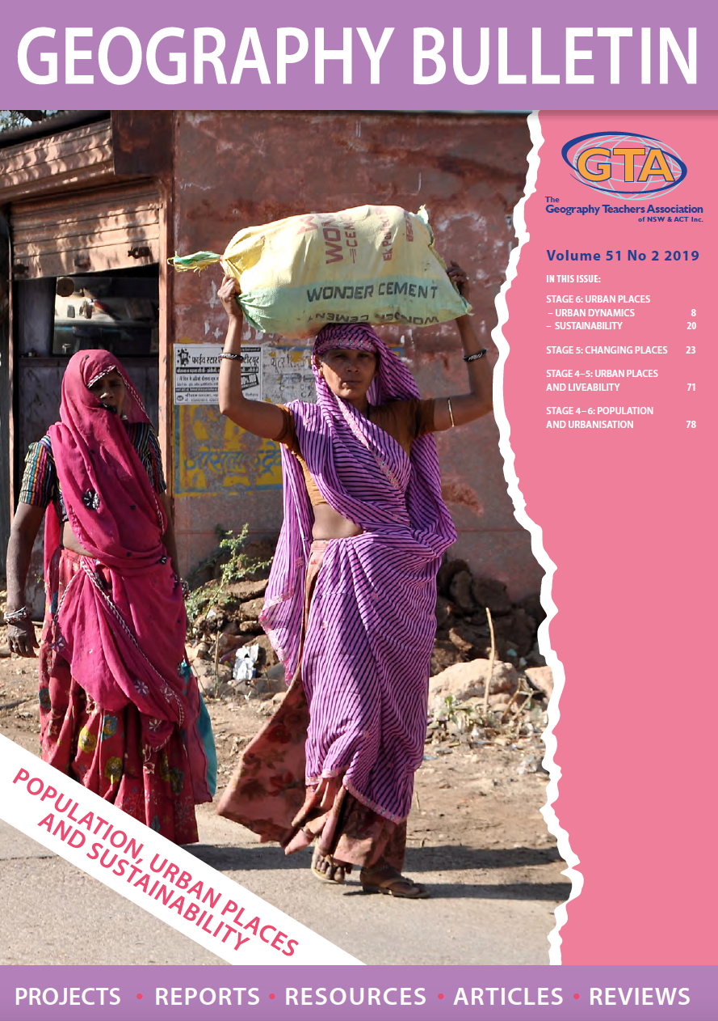

For Activity 1 students will need a copy of the article ‘How to develop a sustainable community in Australia’s fastest growing city”
For Activities 2 – 4 students will need a copy of the article “Sydney’s Darling Harbour”

URBAN PLACES: GREEN SQUARE

ACTIVITY 1:

Before reading the article ‘How to develop a sustainable community in Australia’s fastest growing city” list 5 features you would expect to see in a sustainable community

Read the article and identify 5 features of Green Square that may match the ideas you presented above.

Add additional features of Green Square that contributed to the 6 Star Green Rating received from the Green Building Council of Australia

URBAN PLACES: DARLING HARBOUR

Activities 2-4 are based on the article “Sydney’s Darling Harbour” Bulletin No 51, No 2

ACTIVITY 2: BLACKOUT

Black out the text that is not important in the article (or selected pages) rather than highlighting the important information.

- Working pairs or small groups to complete the blackout.
- Contribute to a class discussion of the important information and consider the perspectives of different class members on what is considered most important.
- Mind map the urban dynamics raised during the discussion.
ACTIVITY 3: TEN PLUS TEN
At the completion of Activity 2
- Create a glossary of ten concepts with a definition for each
- Identify places that exemplify each concept (Illustrative examples)

Concepts x 10 | Meaning / definition | Places x 10  (Illustrative examples)

ACTIVITY 4: 15 MINUTES ON ….
Urban dynamics and Sydney’s Darling Harbour

Location

Urban dynamics identified as important in changing Darling Harbour

Annotate the images with words that summarise ideas presented in the article

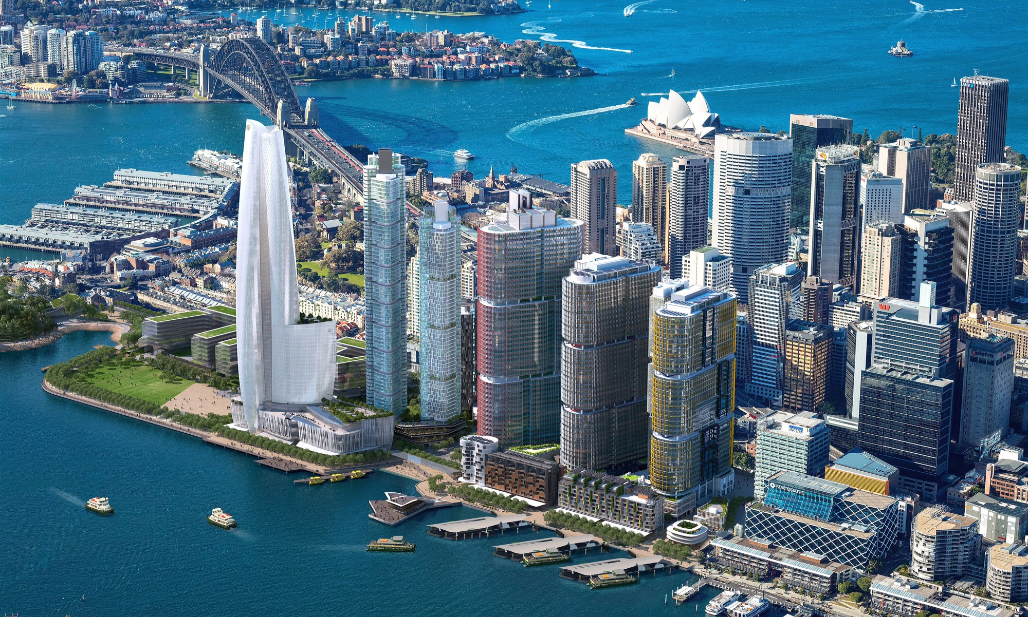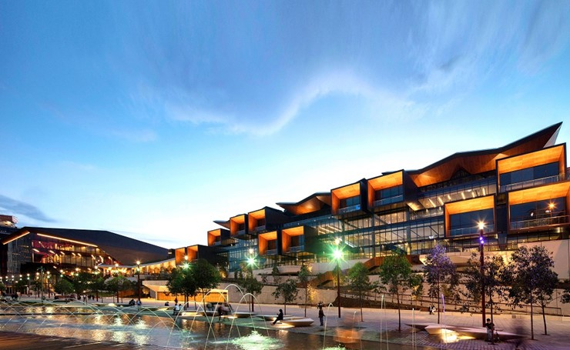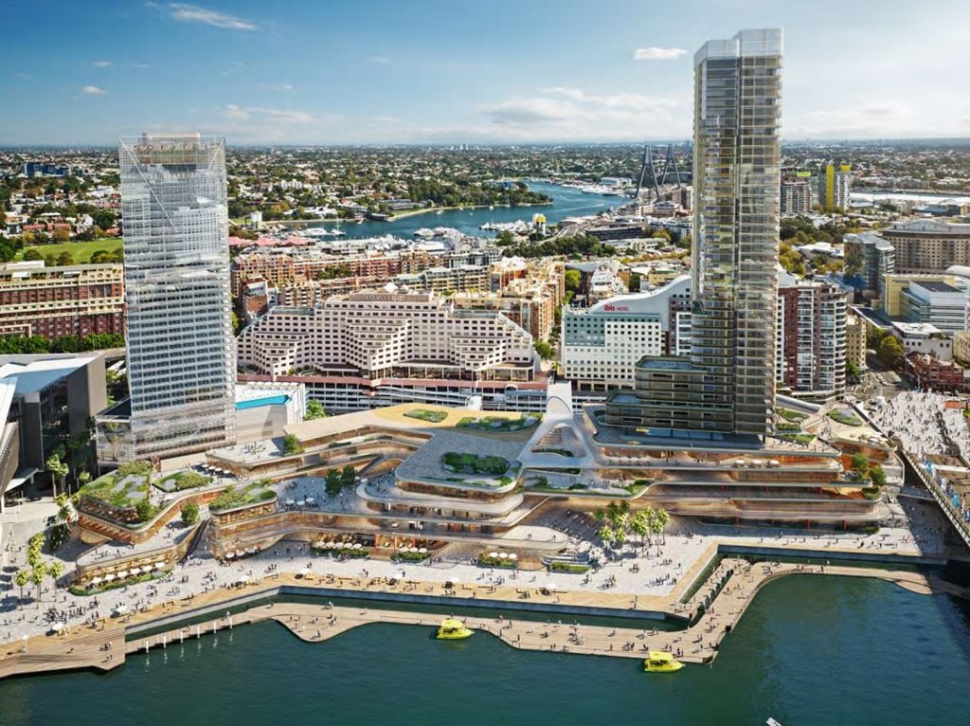

Write a response to this question.

How does the changing economic, social and environmental character of Darling Harbour reflect the operation of a range of urban dynamics?

