STUDENT ACTIVITIES

The Geography Bulletin 2018 Edition 3 (Volume 50 No 3)
https://www.gtansw.org.au/members/login.php

This document has been provided in both PDF and Word formats to allow teachers to add or delete elements as appropriate to their students. Ideas adapted from various Twitter feeds.

Login to your account to access the GTA Bulletins and individual articles for printing

A guideline for teachers is provided on the next page.

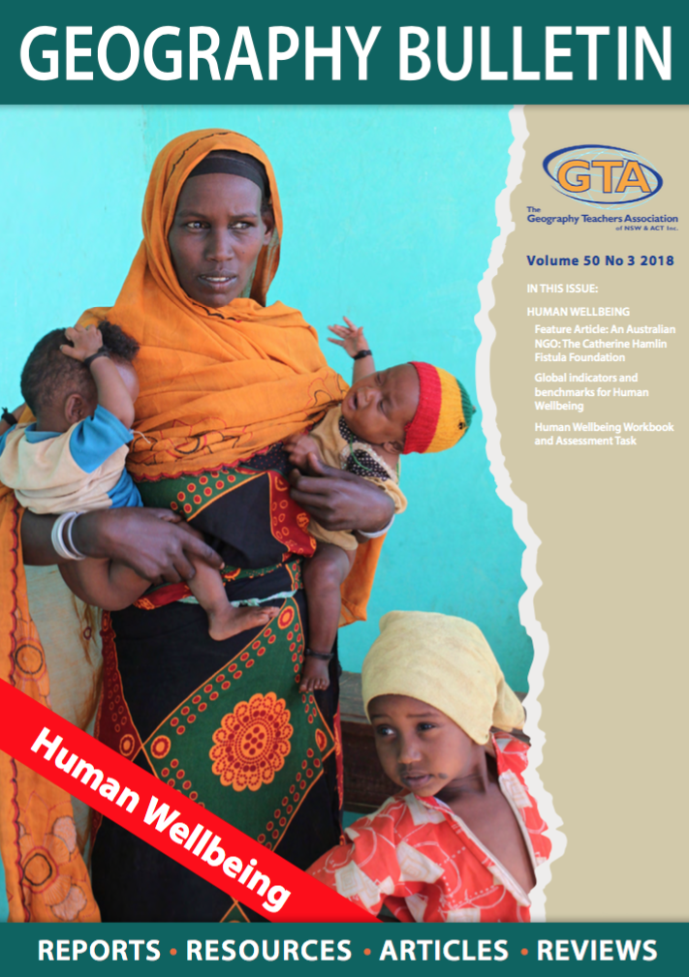

HUMAN WELLBEING

Note: students need a printed copy of the article to complete these activities.
Print copies of the article: An Australian NGO: The Catherine Hamlin Fistula Foundation

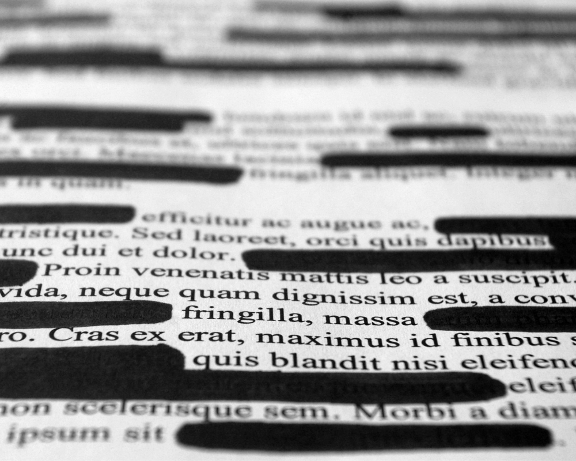
ACTIVITY 1: BLACKOUT

This activity requires students to black out the text that is not important in the article (or selected pages) rather than highlighting the important information.

Highlighting is a safe option as the text remains under the highlighting - if they make a mistake they have not lost the information completely.

By requiring students to black out information considered unimportant, they will think more carefully about their choices. They will work together to check their choices before blacking out text.

- Students working pairs or small groups to complete the blackout.
- They contribute to a class discussion of the important information remaining and consider the perspectives of different class members on what is considered important content.
- Students create a mind map to summarise the important ideas or information identified in the class discussion. If the entire article is used, students may need to create several mind maps with different headings.

NOTE: Depending on the class, the article could be divided into sections.
All groups receive a copy of the material selected for the introduction.
Allocate other sections to different groups.

ACTIVITY 2: SPEAK GEOGRAPHY
At the completion of Activity 1 Students create a vocabulary list of SIX key geographical concepts and write a definition for each.

Concept | Meaning

ACTIVITY 3: 15 MINUTES ON ….
The Hamlin Fistula Foundation

Location

5 challenges faced by different women in the article

Annotate the images with words on the causes, impacts and solutions to fistula

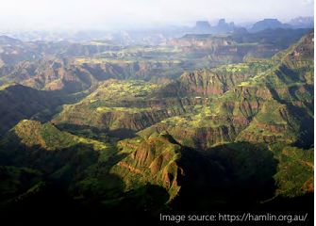
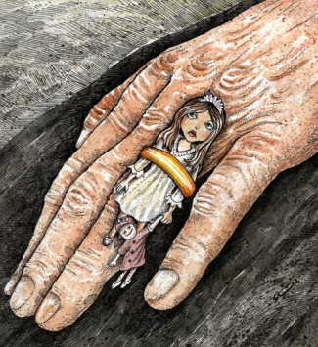
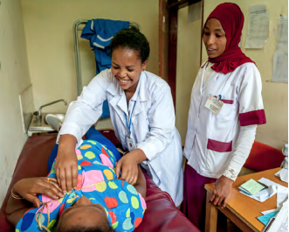
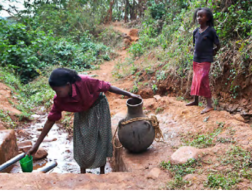

Photos: https://hamilin.org.au/ Cartoon by Reza Mokhtarjozani /USA https://www.icorn.org/article/womens-rights-cartoons

Write a response to this question.

How does the work of the Hamlin Fistula Foundation improve the wellbeing of women?

