

**STUDENT ACTIVITIES**

The Geography Bulletin 2019 Edition 1 (Volume 51 No 1)

<https://www.gtansw.org.au/members/login.php>

This document has been provided in both PDF and Word formats to allow teachers to add or delete elements as appropriate to their students. Ideas adapted from various Twitter fees.

Login to your account to access the GTA Bulletins and individual articles for printing

A guideline for teachers is provided on the next page.

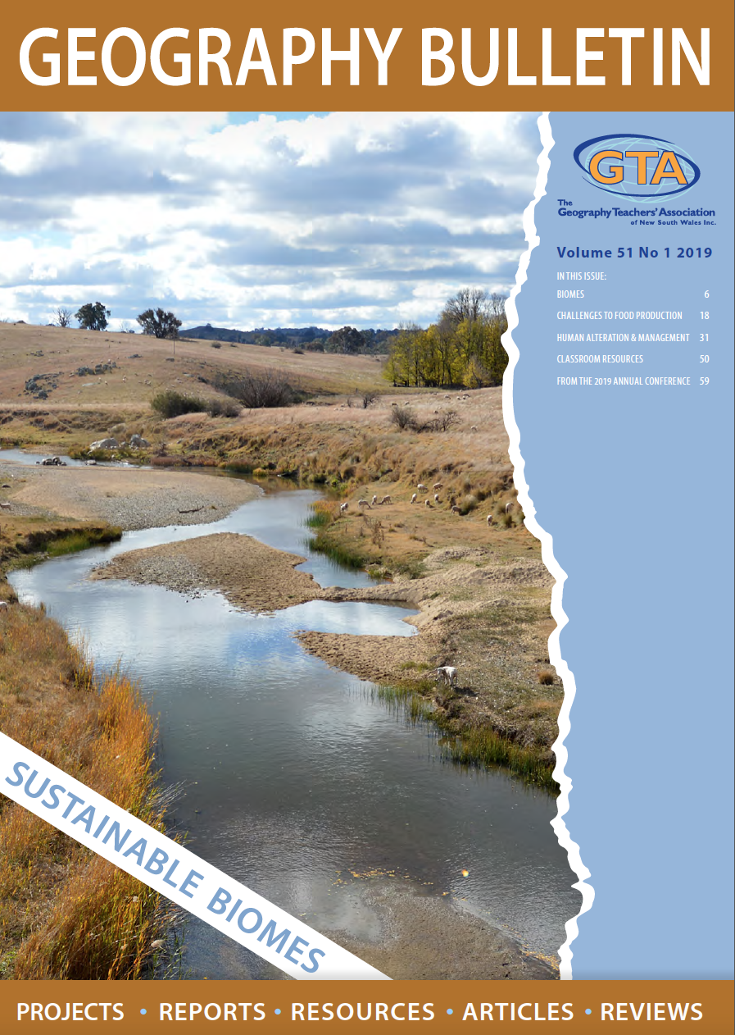

**SUSTAINABLE BIOMES: STOP THE BUS REVISION**

Read *Introduction to Biomes* Bulletin No 51, No 1 pp. 8-12

Check that your class has addressed the inquiry questions during the unit Sustainable Biomes

This is an end of topic activity to check student knowledge and understanding

**Note: Students DO NOT NEED THE ARTICLE TO COMPLETE THIS ACTIVITY.**

**Organisation**

* Students are organised into groups
* Each student completes the worksheet until a STOP THE BUS is called.
* Group members discuss their answers and allocate marks to individual answers (by consensus)
* Teacher is the umpire if there is disagreement.
* Groups share ideas for each question with the class and add depth to their own responses

**Instructions**

* The aim of this activity is to provide 4 facts or ideas in response to each question.
* Students demonstrate knowledge and understanding about the topic area.
* Bonus marks are given for correct information not given by other group members and attempting the challenge questions
* The first person to fill in 5 relevant responses to each question calls “STOP THE BUS” and all students STOP WRITING.

**Scoring**

* 3 marks for bonus questions
* 2 marks for an answer no one else has
* 1 mark for a correct answer
* 0 marks for an incorrect answer.

**CHALLENGES TO FOOD PRODUCTION**

**Note: Students NEED THE ARTICLE TO COMPLETE THESE ACTIVITIES.**



**1. PIECES OF PIE**

This activity is based on the article *“Farming on Thin Ice”* Bulletin No 51, No 1 pp 23-25

* Students will need a copy of the article to complete this activity.
* They complete the pieces of pie with key ideas from the responses of Anika Molesworth and Bianca Das to questions about the global challenges that impact on agriculture.
* 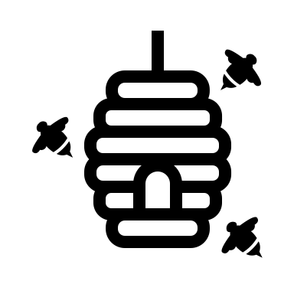Create a colour key for each person and record key ideas for each in the pieces of pie beside each question.

**2. CONSEQUENCE and FLOW CHARTS**

This activity is based on the article *Bees, Biomes and Food security* Bulletin No 51, No 1 pp 20-22

* Students will need a copy of the article to complete this activity.
* After reading the article, listening to the podcast using the link on page 26 and studying the infographic on page 22 (or use the weblink) students
* Summarise consequences of a global loss of bees on the Consequence Chart
* Create a Flow Diagram to show how ONE strategy to protect bees can have a positive impact on food production and food security

NOTE: A4 sized charts can be printed from the Global Education website for this activity if required

<https://www.globaleducation.edu.au/verve/_resources/flow_chart.pdf>

<https://www.globaleducation.edu.au/verve/_resources/consequences_chart.pdf>

**STOP THE BUS GAME 1: Biomes and agriculture**

**Name: _________________________________**

|  |  |  |  |  |  |
| --- | --- | --- | --- | --- | --- |
| **Question** | **1.** | **2.** | **3.** | **4.** | **Score** |
| What makes the world’s biomes different to each other? |  |  |  |  |  |
| What does the primary productivity of a biome mean? |  |  |  |  |  |
| How does primary productivity vary between biomes? |  |  |  |  |  |
| Why are some biomes able to produce higher yields from agriculture than others? |  |  |  |  |  |
| How do people use and alter biomes for agricultural production? |  |  |  |  |  |
| What are the consequences of altering biomes to grow agricultural products? |  |  |  |  |  |
| What strategies are used to minimise the impacts of agricultural activities? |  |  |  |  |  |
| CHALLENGE QUESTION  Should biome maps include anthropogenic biomes? |  |  |  |  |  |

**STOP THE BUS GAME 2: Sustainable Biomes & Food Security**

Name_______________________________

|  |  |  |  |  |  |
| --- | --- | --- | --- | --- | --- |
| **Question** | **1.** | **2.** | **3.** | **4.** | **Score** |
| What challenges limit the potential of agriculture to increase food production? |  |  |  |  |  |
| How can technology help to overcome challenges to global food production? |  |  |  |  |  |
| What is food security? |  |  |  |  |  |
| What factors influence food security in different places? |  |  |  |  |  |
| What strategies can be used to increase global food security? |  |  |  |  |  |
| Can the world’s biomes sustainably feed the world’s population? |  |  |  |  |  |
| CHALLENGE QUESTION  Can all food production systems be more sustainable? |  |  |  |  |  |

**PIECES OF PIE: Challenges to food production**

Name ______________________________________

How did you discover you love for agriculture and interest in international agricultural development?

What do you see as the big challenges facing the sustainability of our planet?

What are you doing about tackling these challenges?

What is the role of women in agriculture?

A

Anika Bianca

List three actions individuals such as yourself could take to address global challenges to food production.

________________________________________________________________________________________________________________________________________________________________________________________________________________________________________________________________________________________________________________________________________________________________________________________________________________________________________________________________________________________________________________________________________________________________________________________________________________________________________________________________________________________________________________________________________________

**CONSEQUENCE & FLOW CHARTS: Challenges to food production**

Name ______________________________________

Summarise TWO consequences of a global loss of bees and two flow on effects of each consequence

Show how ONE strategy to protect bees can have a positive impact on food production and food security.

