Appendix 1: Student activities for Tundra Investigative Study

Created by Louise Swanson for GTANSW & ACT

The Geography Bulletin 2019 Edition 3 (Volume 51 No 3)
https://www.gtansw.org.au/members/login.php
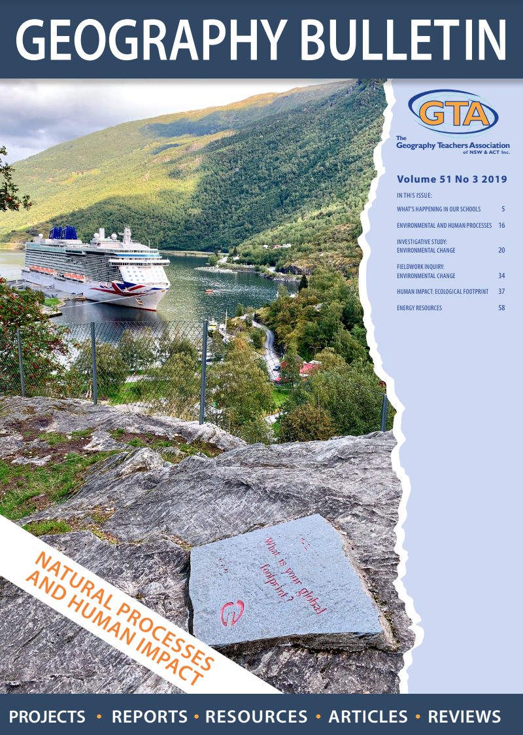

This document has been provided in both PDF and Word formats to allow teachers to add or delete elements as appropriate to their students.

Login to your account to access the GTA Bulletin and individual articles for printing where required.

For Activity 2 parts A – F, students will need a copy of the article ‘Subarctic and subantarctic Tundra Investigative study’

Instructions are provided with each activity.

Activity A: Skills – Climate graphs

A climate graph is a graph which shows the annual rainfall and temperature at a particular location. The rainfall (or precipitation) is indicated by a blue bar for each month.
The temperature is indicated by a line on the graph showing the temperature for each month. This line is red.
The months of the year are on the bottom axis of the graph. Temperature is usually on the right axis and rainfall is usually on the left axis.
​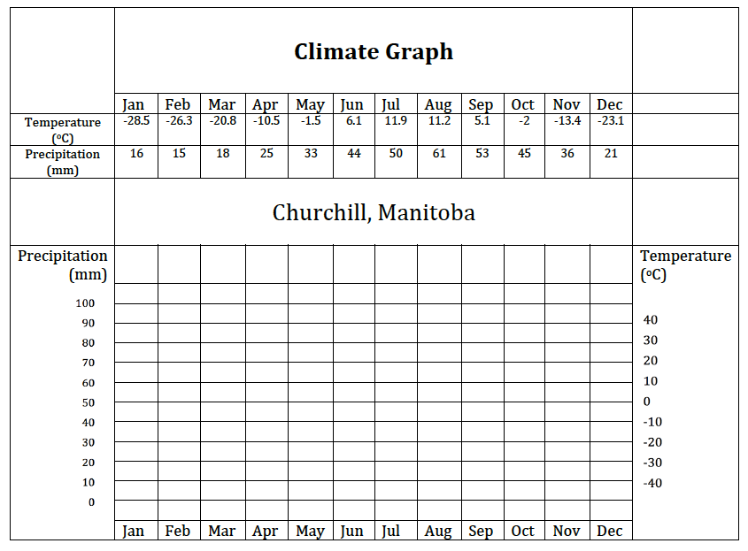

Describe the climate at Churchill using the following concepts – maximum and minimum average temperature, annual temperature range, annual precipitation and its distribution.

_________________________________________________________________________________________________________________________________________________________________________________________________________________________________

Activity B: Tundra – Virtual Fieldwork

Fieldwork: Hudson Bay
Some schools may be able to do a field trip to Canada, however, for most schools if you use this case study, the best option would be to complete fieldwork on Environmental Change as a general topic in your local area, and complete virtual fieldwork on this case study. Below are some options to help you do this.
​​
Observations
An important initial step in any fieldwork trip is observation. An observation helps provide the researcher with a broad view of the environment and can help frame initial research questions or provide general information about basic questions in your research.
Explore how the Google Maps team are helping build and share a Google Maps Tour of Churchill
See https://www.youtube.com/watch?time_continue=113&v=QYhoz54hpc8
​Line drawing/Photosketch

Tools:
- pen,
- paper,
- eraser,
- ruler

Students:
Examine the scene and settle on a particular view
Draw a box (frame) for your sketch in the space below.
Draw a general outline of the view.
Label key features of the view on your photosketch or line drawing. The items that you label may depend on the focus of your research questions.
Include a heading, the date of the sketch and the website the view was sketched from.

Activity 3: Causes and consequences of environmental change
Impact on the lithosphere
………………………………………………………………………………………………………………………………………………………………………………………………………………………………………………………………………………………

Climate change
………………………………………………………………………………………………………………………………………………………………………………………………………………………………………………………………………………………………………………………………………………………………………………………………………………………………………………………………………………………………………………………………………………………………………………………………………………………………………………………………………………………………………………………………………………………………………………………………………………………………………………………………………………………………………………………………………………………………………………………………………………………………………………………………………………………………………

Impact on the atmosphere
………………………………………………………………………………………………………………………………………………………………………………………………………………………………………………………………………………………

Impact on the biosphere
………………………………………………………………………………………………………………………………………………………………………………………………………………………………………………………………………………………

Impact on the hydrosphere
………………………………………………………………………………………………………………………………………………………………………………………………………………………………………………………………………………………

Activity 4: Topic Overview

Use the scaffold below to create a brief summary of the tundra environments investigative study.

 | McDonald Island and Heard Islands Reserve and World Heritage Area,  AUSTRALIA | Churchill Wildlife Management Area,  CANADA
 | BIOPHYSICAL PROCESSES
Describe the biophysical processes that occur in tundra environments.

Explain how the biophysical processes enable tundra environments to function.

 | CAUSES, EXTENT & CONSEQUENCES OF CHANGE
Examine the causes and extent of change to tundra environments.

Analyse the short and long-term consequences of environmental change.

 | MANAGEMENT OF ENVIRONMENTAL CHANGE
Describe management strategies implemented to protect tundra environments.

Discuss the factors influencing the management responses eg worldviews,
competing demands, technology, climate change

Compare and evaluate the effectiveness of the management responses in achieving
environmental sustainability.

Propose how individuals could contribute to achieving environmental sustainability for tundra
environments.

Use the VENN DIAGRAM below to show key similarities and differences between
McDonald Island and Heard Islands Reserve and World Heritage Area, Australia AND
Churchill Wildlife Management Area, CANADA.

Activity 5: Writing Task

Analyse the short, and longer-term consequences of environmental change in tundra environments. Refer to both Churchill, Canada and McDonald and Heard Islands, Australia in your response. Use this planning scaffold for your answer.

Introduction
Short term consequences - overview
Short term consequences - Churchill
Short term consequences – Heard and McDonald Islands
Long term consequences - overview
Long term consequences - Churchill
Long term consequences – Heard and McDonald Islands
Conclusion

Activity 6: Individual action

Task: Propose how individuals could contribute to achieving environmental sustainability for tundra environments.

Pre-task planning:

What is environmental sustainability?
To define environmental sustainability, we need to consider the functions of the environment: source, sink, service and spiritual.
- Source: the capacity of the environment to provide us with materials we rely on such as timber, water and soil.
- Sink: the ability of the environment to remove and breakdown waste.
- Service: processes that enable our existence such as stabilising the climate.
- Spiritual: how the environment provides us with psychological benefits or spiritual connections

Definition: ………………………………………………………………………………………………………………….
……………………………………………………………………………………………………………………………………

Suggestion some actions that individuals can take to address the environmental sustainability of tundra environments.

Individual action | Does it address the source, sink, service, or spiritual function? Which one? | Briefly state how it addresses the function (source, sink, service or spiritual).
Task: Write a persuasive response that proposes how individuals could contribute to achieving environmental sustainability for tundra environments.

Introduction:
……………………………………………………………………………………………………………………………………
……………………………………………………………………………………………………………………………………
……………………………………………………………………………………………………………………………………
……………………………………………………………………………………………………………………………………
……………………………………………………………………………………………………………………………………

Paragraph 1: Describe an action an individual could take and explain how it addresses environmental sustainability for tundra environments.
……………………………………………………………………………………………………………………………………
……………………………………………………………………………………………………………………………………
……………………………………………………………………………………………………………………………………
……………………………………………………………………………………………………………………………………
……………………………………………………………………………………………………………………………………
……………………………………………………………………………………………………………………………………

Paragraph 2: Describe an action an individual could take and explain how it addresses environmental sustainability for tundra environments.
……………………………………………………………………………………………………………………………………
……………………………………………………………………………………………………………………………………
……………………………………………………………………………………………………………………………………
……………………………………………………………………………………………………………………………………
……………………………………………………………………………………………………………………………………
……………………………………………………………………………………………………………………………………

Paragraph 3: Describe an action an individual could take and explain how it addresses environmental sustainability for tundra environments.
……………………………………………………………………………………………………………………………………
……………………………………………………………………………………………………………………………………
……………………………………………………………………………………………………………………………………
……………………………………………………………………………………………………………………………………
……………………………………………………………………………………………………………………………………
……………………………………………………………………………………………………………………………………
Paragraph 4: Describe an action an individual could take and explain how it addresses environmental sustainability for tundra environments.
……………………………………………………………………………………………………………………………………
……………………………………………………………………………………………………………………………………
……………………………………………………………………………………………………………………………………
……………………………………………………………………………………………………………………………………
……………………………………………………………………………………………………………………………………
……………………………………………………………………………………………………………………………………

Conclusion:
……………………………………………………………………………………………………………………………………
……………………………………………………………………………………………………………………………………
……………………………………………………………………………………………………………………………………
……………………………………………………………………………………………………………………………………
……………………………………………………………………………………………………………………………………

Peer feedback
Swap your work with another person in your class. Read the other person’s work.
- Highlight the individual actions proposed.
- Underline each example of persuasive language used.
- Circle each time the writer has referred to source, sink, service or spiritual functions.
What are the positive features of this piece of writing?
……………………………………………………………………………………………………………………………………
……………………………………………………………………………………………………………………………………
……………………………………………………………………………………………………………………………………
What is something the person could do to improve their writing?
……………………………………………………………………………………………………………………………………
……………………………………………………………………………………………………………………………………
……………………………………………………………………………………………………………………………………
Review
Spend a few minutes reviewing the comments and markings of your peer. Spend five minutes editing your work based on their feedback.

Activity 7: Evaluating Management Responses

Extended response
Evaluate the effectiveness of management of environmental change in tundra environments.
You will need to make a judgement about the benefits and costs of management strategies implemented to protect tundra environments.
- How effective are the management strategies?
- How can communities and governments attempt to balance environmental, economic and social criteria?
- To what extent can there be trade-offs between them?
- What are the practical and ethical dilemmas of national and international conservation programs?
- Are the management strategies addressing environmental sustainability?
In your response to this question you will need to describe the management strategy AND make a judgement about how effective it is. Use terms such as totally ineffective, somewhat ineffective, moderately effective, very effective.

What are some other words you can use? Add words to the table below.

Totally ineffective | Somewhat ineffective | Moderately effective | Very effective
Least |  |  | Most
Unsuccessful  Unproductive  Impractical  Useless  Fruitless  Inadequate  Unworkable |  |  | Successful  Productive  Practical  Useful  Fruitful  Valuable  Worthwhile  Gainful
When you have completed your extended response, edit your work, checking for:
- Correct grammar and punctuation
- Correct spelling
- Use of geographical terms
- Is there anything that needs more depth?
- Have you indicated how effective the management strategies are?

Complete the scaffold below to help you complete an extended response on the effectiveness of management of environmental change in tundra environments.

Management Response and where it is implemented | Describe the response | Is it effective? | Does it address environmental sustainability? | Are there any practical or ethical issues?

