Appendix 2 - Minnamurra River: From Source to Sea

Created by Andy Grant, Suzanne Johnson, Mark Peters and David Brennan
for GTANSW & ACT

The Geography Bulletin 2019 Edition 3 (Volume 51 No 3)
https://www.gtansw.org.au/members/login.php

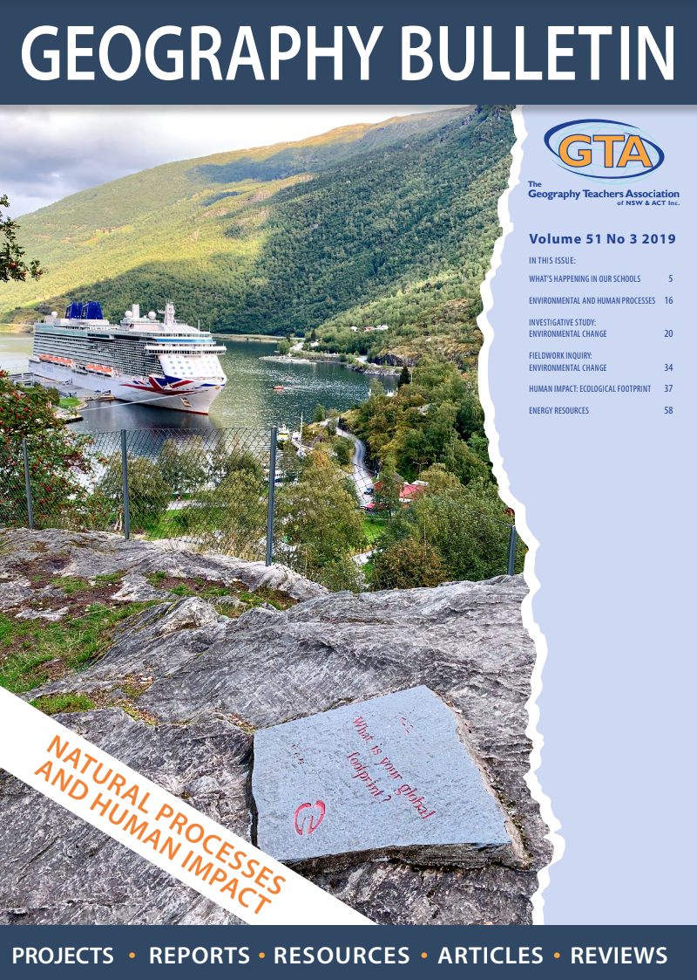

This document has been provided in both PDF and Word formats to allow teachers to add or delete elements as appropriate to their students.

Login to your account to access the relevant GTA Bulletin article.

The following data collection sheets are to be used by students when undertaking the
Minnamurra River: From Source to Sea Fieldwork activity or similar fieldwork activity in another location.
Minnamurra River: From Source to Sea
Data Record
In the space below you are to record the results at 3 different locations and provide possible reasons for the results you have collected.
Site One: Minnamurra Rainforest | Coordinates
Water temperature  1.  2.  3. | Turbidity  1.  2.  3.
Flow rate  1.  2.  3. | Gradient  1.  2.  3.
Role of river at this location

Evidence and purpose of management

General observations

Minnamurra River: From Source to Sea
Data Record Sheet
In the space below you are to record the results at 3 different locations and provide possible reasons for the results you have collected.
Site Two: Swamp Road | Coordinates
Water temperature  1.  2.  3. | Turbidity  1.  2.  3.
Flow rate  1.  2.  3. | Gradient  1.  2.  3.
Role of river at this location

Evidence and purpose of management

General observations

Minnamurra River: From Source to Sea Data Record Sheet
In the space below you are to record the results at 3 different locations and provide possible reasons for the results you have collected.
Site Three: Mud Flats, Minnamurra Boat Ramp | Coordinates
Water temperature  1.  2.  3. | Turbidity  1.  2.  3.
Flow rate  1.  2.  3. | Gradient  1.  2.  3.
Role of river at this location

Evidence and purpose of management

General observations

