Appendix 3: Student activities for ECOLOGICAL FOOTPRINT

Created by Dr Susan Bliss for GTANSW & ACT

The Geography Bulletin 2019 Edition 3 (Volume 51 No 3)
https://www.gtansw.org.au/members/login.php

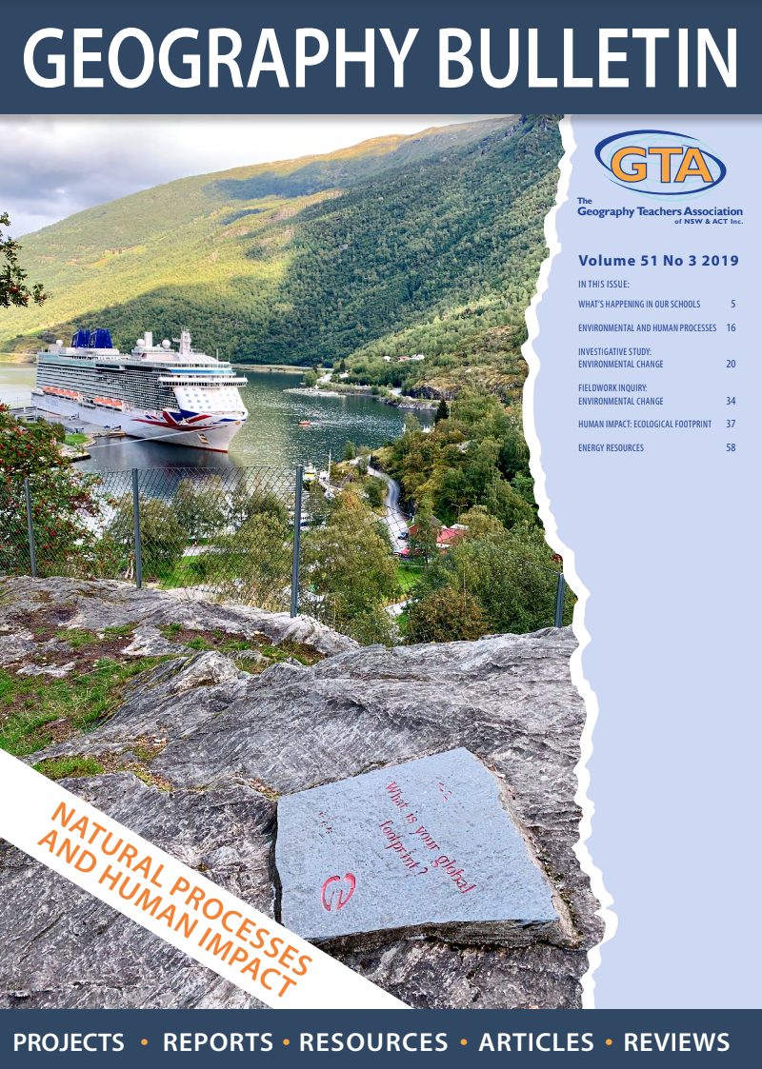

This document has been provided in both PDF and Word formats to allow teachers to add or delete elements as appropriate to their students.

Login to your account to access the GTA Bulletins and individual articles for printing where required.

Instructions are provided with each activity.

Students will need a copy of the article ‘Ecological Footprint’ by Dr Susan Bliss

INVESTIGATING ECOLOGICAL FOOTPRINTS

- Read the following material to complete the activities below
A. What is the Ecological Footprint?
The following abstract

AUSTRALIA’S CHANGING ECOLOGICAL FOOTPRINT

This activity encourages students to view the ecology of the land, resources, liveability, and human-environmental interactions, from different perspectives.

The Palmer River, 140 km south-west of Cooktown, was originally inhabited by Aboriginal people such as the Kuku-Yalanji, who lived a subsistence lifestyle. Survival was dependent on the exploitation of food that varied seasonally. The uncertain supply of wild game resulted in either feast or famine.
In 1873, when gold was discovered large populations of Chinese immigrants (mostly from Guangdong Province) followed but suffered at the hands of many Europeans. From 1873-1885, Maytown became the centre of the Palmer gold rush. The landscape was transformed into frontier townships and prospecting camps along the Palmer River. By 1874 there were over 5,000 Europeans and 2,000 Chinese working the Palmer River. The Aboriginals were reduced to living in shanty towns.
With the demise of easily accessible gold, the Palmer River area became occupied by large landholdings, some running cattle.

Aboriginal people living on the eastern coast of Cape York had little contact with non-Indigenous people prior to the 1850s. However, the discovery of gold in north Queensland affected the lives of tens of thousands of people. Aboriginal people were proud of their cultural distinctiveness and were actively resistant to alien intrusion. For Oscar, an Aboriginal boy, it meant being separated from his culture and being forced to adapt to a new life as a stockman. Oscar and other Aborigines had to compete with goldminers for their own lands. They were often subjected to violence and forced to adapt to new ways of life. Through his drawings Oscar produced a detailed record of what must have been some of the most influential events of his young life.
Adapted: https://www.sbs.com.au/gold/story.php?storyid=102

In the days of Palmer River gold rush this goldfield was the centre of activity for the whole Cape York Peninsula. Today it is a historical site. The Kuku-Yalanji people registered a Native Title Claim over parts of their traditional land in May 1995.

- Draw a timeline showing how human activity has changed the environment of the Palmer River area.
- Identify who had the smallest ecological footprint (EF)? Provide reasons for your answer.
- Describe how the different ecological footprints changed the fragile Australian landscape in a short period of time.
- Investigate how Aboriginal peoples had been able to live productively on the resources available. Present as a short report using ICT
- Comment on this quote: “Indigenous peoples have contributed the least to world greenhouse gas emissions and have the smallest ecological footprints on Earth. Yet they suffer the worst impacts such as climate change”. https://www.eurekalert.org/pub_releases/2008-04/unu-iph040108.php
- Literacy: Write a narrative depicting life and the EF in the year 3000.
- Visual literacy: Provide two photographs. One related to traditional Aboriginal lifestyles in a small community/village and another showing present day Australians living in a capital city. Compare these two lifestyles and the use of energy, water and waste generated.

- Read
B. How does the EF measure the impact of humans on the environment?

- What does the EF measure?
- By adding up six withdrawals, we can calculate the human footprint (a measure of how much we are using the Earth’s natural resources). The withdrawals come in six categories: List them.
- Explain why this measurement is considered as an indicator of sustainability.

- Refer to the Graph Global EF Trends to answer these questions

- What was the largest component of the EF in 1961 and 2014?
- Calculate the changes to the six components from 1961 to 2014.
- Discuss the reasons for these changes.

- Refer to the graphs showing the countries with the largest EF and largest EF per person to answer these questions

- Name the country that has the largest EF and the largest EF per person.
- Calculate the global hectares (gha) of carbon per person for Qatar and United Arab Emirates (UAE). Investigate reasons for the large production of carbon per person.

- Refer to the graph - Share of World’s carbon footprint

- Use the carbon footprint tool to calculate your footprint. Compare your footprint with the rest of your classmates. Summarise your findings https://footprint.wwf.org.uk/#/

- Read:
Running shoes leave large carbon footprint.
Huge carbon footprint of a sandwich

- Greenhouse gas emissions are produced by growing crops, aquaculture, rearing animals, as well as processing, transporting, storing, cooking and disposing of food you eat.
What are the impacts of food on the carbon footprint?
How can you reduce your food carbon footprint?
http://www.greeneatz.com/foods-carbon-footprint.html

- Refer to the composite column graph: Compare the carbon footprint between the urban very rich and the rural very poor. https://www.bbc.com/news/science-environment-46459714

- Refer to:
C. What is the demand side of EF? Let’s look in your wardrobe!

- What resources are required to produce clothes (cotton, synthetics) that contributes to the EF?
- Explain how recycled clothes can reduce the EF.
- Research the EF of a pair of jeans. Divide into environmental and social costs. https://www.activesustainability.com/sustainable-life/do-you-know-your-clothes-ecological-and-social-footprint/; https://bronwynvanvugt.wordpress.com/2013/01/26/the-cost-of-a-pair-of-jeans/; https://www.vice.com/en_au/article/kzzpjm/your-jeans-are-ruining-the-earth-v24n7; https://theconversation.com/sustainable-shopping-for-eco-friendly-jeans-stop-washing-them-so-often-75781; https://globalaspect.wordpress.com/2014/01/24/life-cycle-of-a-jean-and-our-clothing-footprint/
- Suggest solutions to sustainable fashion

- Read:
What do you throw away?
Where is the missing plastic?
What do you do with the waste from consumption?

- What is the carbon footprint of plastic? http://stopplastics.ca/carbon-footprint-plastic; https://timeforchange.org/plastic-bags-and-plastic-bottles-CO2-emissions; https://sciencing.com/carbon-footprint-plastic-bottle-12307187.html
- What can you do as an active, informed citizen to reduce the use of plastic?
- In groups research the Great Pacific Garbage Patch. Include where it is, source of the garbage, its size, quantity of rubbish, effects on humans and marine life, solutions and research. https://www.theoceancleanup.com/great-pacific-garbage-patch/; https://www.nationalgeographic.org/encyclopedia/great-pacific-garbage-patch/; https://www.wwf.org.au/news/blogs/how-can-we-destroy-the-great-pacific-garbage-patch#gs.1ywbgi

- Read:
D. What is the supply side of the EF? Biocapacity
E. What is the environmental problem?
F. What is meant by Ecological Overshoot? Is this a problem?

- In groups mind map responses to the following question. “How do we decrease our resource use and at the same time create a future that provides food, water and energy for about 9 billion people that will share the planet in 2050”?
- Suggest how we could return to ‘one-planet living’ by 2050.
- Explain this statement. “The best tool for measuring human impacts on the planet may be a dashboard of environmental indicators, not a footprint.” https://theconversation.com/yes-humans-are-depleting-earths-resources-but-footprint-estimates-dont-tell-the-full-story-100705

- Ecological overshoot. Identify the main message in each of these articles

https://wwf.panda.org/knowledge_hub/all_publications/living_planet_report_timeline/lpr_2012/demands_on_our_planet/overshoot/

https://theconversation.com/yes-humans-are-depleting-earths-resources-but-footprint-estimates-dont-tell-the-full-story-100705

- Read:
G. What are the inequalities between EF at a variety of scales?
H. How can you reduce the EF? Active citizenship

  - List all the environmentally friendly activities you perform in the home and at school?
  - How can you live a more sustainable lifestyle?

