APPENDIX 4: STUDENT ACTIVITIES for ECOLOGICAL FOOTPRINT

Created by Dr Susan Bliss for GTANSW & ACT

The Geography Bulletin 2019 Edition 3 (Volume 51 No 3)
https://www.gtansw.org.au/members/login.php

This document has been provided in both PDF and Word formats to allow teachers to add or delete elements as appropriate to their students.

Login to your account to access the GTA Bulletins and individual articles for printing where required.

Instructions are provided with each activity.
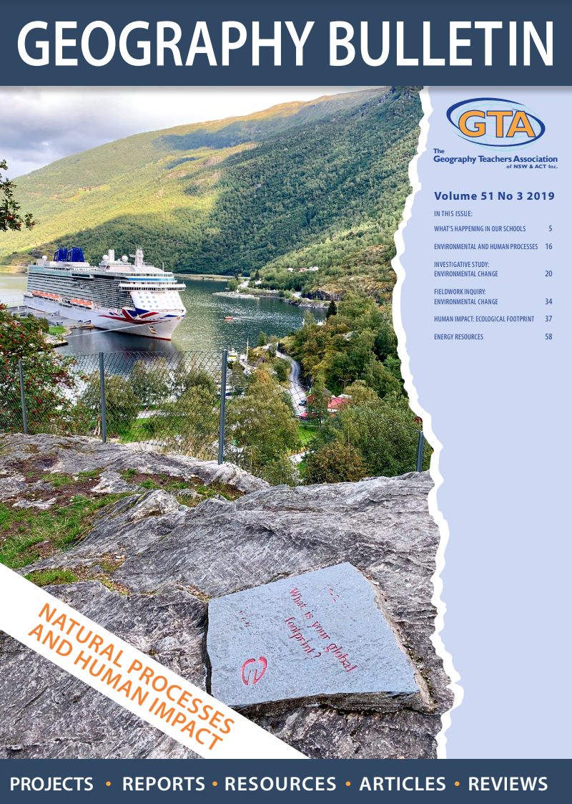

Students will need a copy of the article ‘Ecological Footprint’ by Dr Susan Bliss

INVESTIGATING ECOLOGICAL FOOTPRINT

ADDITIONAL ACTIVITIES
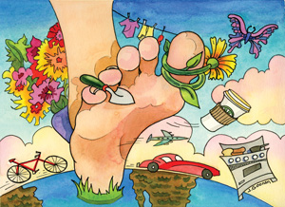

http://ecomerge.blogspot.com/2009/06/whats-your-ecological-footprint.html

USING ICT: EF AT A PERSONAL SCALE
- Crunching the numbers. Calculate your ecological footprint and compare it with your parents and peers. Who was closest to 2.1 global hectares (average amount of biocapacity per person)?
http://www.footprintcalculator.org/
http://www.footprintcalculator.org/signup?gclid=EAIaIQobChMIhYWvrLf54gIVViQ
http://www.esb.utexas.edu/drnrm/EcoFtPrnt/v7HouseHoldEcoFtPrnt.xls.
- Follow the quiz and discover the impact you have on the planet

https://www.earthday.org/take-action/footprint-calculator/
- Identify ways you can become a responsible consumer.

http://www.moneystuff.net.au/teachers/print/pdfVic/10_commerce_section_f.pdf
- Imagine your lifestyle follows the sustainable path. Describe this lifestyle.
- In groups complete the School Ecological Footprint. Summarise your findings and suggest sustainable solutions and their implementation https://www.epa.vic.gov.au/~/media/Publications/1216.pdf

USING ICT: EF AT REGIONAL/NATIONAL/GLOBAL SCALES

- View the video: National Footprint Accounts – Ecological Balance Sheets for 180+ Countries, Compare two countries in the Asian Region. https://www.youtube.com/watch?v=_T5M3MiPfW4&feature=youtu.be

Summarise your findings in a short report
- Refer to Regional Footprints at http://www.unfpa.org/swp/2001/english/ch03.html#2. What region has the highest and lowest EF?

Explain the reasons for the differences.
- Answer the EF Quiz. What is the EF for five countries? http://www.earthday.net/footprint/info.asp and http://www.lead.org/leadnet/footprint/intro.htm
- Outline the reasons for variations in nations EF http://www.ecouncil.ac.cr/rio/focus/report/english/footprint/
- Rich countries gobble up more resources. Explain this statement http://www.akha.org/article67.html

OVERVIEW: IMPACT OF HUMAN ACTIVITIES

- Study the Ecological Footprint Poster at https://www.teachstarter.com/au/teaching-resource/the-ecological-footprint-poster/
What is the environmental impact of the following human activities?
Complete the table with your answers.

Using of fossil fuels | Clearing forests | Disposing of rubbish in land, rivers and ocean | Clearing land for cities, mining and agriculture

- Extension. Discuss EF issues and global trends as a short report? Ecological_Footprint_Issues_and_Trends.pdf
https://pdfs.semanticscholar.org/86f3/6d0fbd47789b789fe82648ecfe9d37ad3f42.pdf
- Suggest actions for a sustainable Earth. http://www.ecovoyageurs.com/EcoSite%20English/Action/take_action.htm

PAIR ACTIVITY
- In pairs, answer these questions to determine whether you are an environmental devil or environmental angel. Adapted: https://www.newscientist.com/article/mg17022888-800-devil-or-angel-2-is-one-planet-enough/

Do you:
- Have showers over 5 minutes?
- Buy packaged and processed items?
- Have an air conditioner?
- Switch off lights in a room no longer in use?
- Leave computers and TVs on standby?
- Walk or cycle to school?
- Recycle paper, cans and plastic containers?
- Compost organic waste?
- List the activities you performed today that used natural resources.
Compare your answer with your partner.
- What steps are you taking to leave a smaller footprint?
- Compare your footprint with the traditional Aboriginal people. Explain why they differ.
- How many Earths would be needed if everyone on the planet enjoyed your standard of living? http://www.footprintcalculator.org/?gclid=EAIaIQobChMIosjo6IWB4QIVBI-PCh2sSA39EAAYASAAEgLsmPD_BwE
https://www.earthday.org/take-action/footprint-calculator/
CLASS ACTIVITY

Divide class of 28 students into continents and distribute food and wealth.
Then complete the following activities

Continents | % of population per continent. | 28 students | Food distribution | Wealth distribution.
Asia (red) | 59% | 17 | 36%  9 chocolates | 13%  3 cents
Africa (yellow) | 11% | 3 | 7%  2 chocolates | 2 %  ½ cent
Europe (black) | 16 | 4 | 31%  8 chocolates | 30%  8 cents
North America (blue) | 8% | 2 | 16%  4 chocolates | 35%  9 cents
South America (green) | 5.5% | 1 | 9%  2 chocolates | 14%  4 cents
Australia (purple) | 5% | 1 | 1%  ½ chocolate | 5%  1 cent

- Are these resources (food and wealth) evenly distributed amongst the continents? Explain your answer.
- Has each continent sufficient food and wealth to provide for their population? Is this fair? Explain your answer.
- Is anyone willing to share their food and wealth? If not-why not?

CARTOON INTEPRETATION

- Are we getting too big for our house?  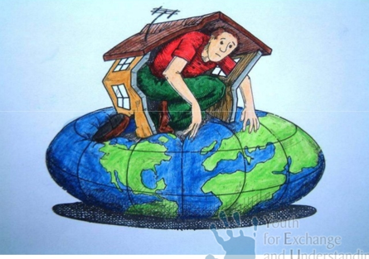  http://www.yeu-international.org/en/publications/newsmail/between-the-lines/eu-countries-are-ones-with-highest-ecological-footprints-what-can-be-the-solution | 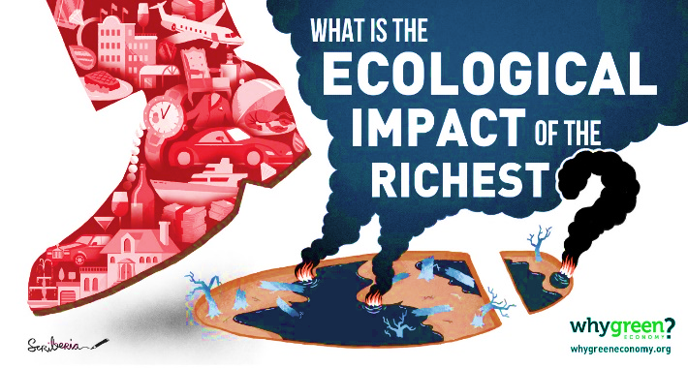  - Who has the largest ecological footprint?  http://whygreeneconomy.org/inequality-of-overconsumption/

- Refer to A. Are we getting too big for our house? Provide explanations.
List three countries with the largest EF and the largest EF per person.
- Refer to B. Compare the footprint of the rich versus the poor https://wwf.panda.org/knowledge_hub/all_publications/living_planet_report_timeline/lpr_2012/demands_on_our_planet/footprint_income/
- Compare the City Slicker and Country Bumpkin’s footprints. Who has the smaller carbon footprint? Explain reasons for the difference. https://www.livescience.com/13772-city-slicker-country-bumpkin-smaller-carbon-footprint.html
- Carbon inequality between rich and poor countries is decreasing, but the urban-rural difference is increasing especially in urbanising developing countries. These inequalities need to be addressed nationally/locally. Explain this statement. https://www.thenatureofcities.com/2017/07/30/urban-rural-inequalities-carbon-emissions/

COUNTRY COMPARISONS-DEVELOPED AND DEVELOPING COUNTRIES

Kerala in southern India, is noted for its successful development. It has achieved a high quality of life similar to Western countries. In spite of its lower per capita income, it has high human development and exceptionally low EF of only 0.7 gha - i.e. each person uses only 70% of the natural resources that they are entitled to for a sustainable world.

 | KERALA, INDIA | CALIFORNIA, USA
Population | 34 million | 39 million
EF | 0.7 gha | 8.6 gha
HDI 2018  - Life expectancy, (2) Education and (3) Per capita income. | 0.790 high (59th position between Turkey and Panama)  High human development | 0.88 (Between Spain and Italy)  Very high human development

- Compare the ecological footprint in Kerala (India) with California (USA). Explain the reasons for the large difference.
- Does a small EF mean deprivation of human wellbeing? Explain your answer.
- Does this mean we can reduce our high EF and at the same time maintain our high standard of living?

CLASS DISCUSSION

Everything involves environmental resources from sandwiches, clothes, sport trainers, to mobile phones. All the ‘stuff’ we consume has an impact on our ecological footprint.
The big questions are:
- When will we run out of useable planet?
- How will this affect human wellbeing?
- What should you do about it?
- Are we ‘talking the talk’ but not ‘walking the walk’? Explain this question.

PERSPECTIVES FROM WORLDWATCH

A Bangladeshi child eats a bowl of rice: an American teen uses a smartphone; a woman in Finland takes an aeroplane to Australia; a man in Zimbabwe fills his car with oil; and Japanese schoolchildren are making origami cranes.
- Name the resources used in this statement
- List the objects you buy and use in a day. Now multiply this by 7.7 billion people on Earth. Do you think there could be a problem? Is this sustainable?
- Refer to the table on different global perspectives.
Is this equity? Explain your answer.

- Excessive consumption burdens societies with bulging landfills; polluted oceans, atmosphere, groundwater, rivers and soil, and declining fish stocks. Results in a large EF e.g. Luxembourg, USA, Australia, Qatar, Bahrain, Dubai. | - Meanwhile, about 50% of the world's population — more than 3 billion people — live on less than $2.50 a day. Results in a low EF e.g. Pakistan, Bangladesh, Haiti
http://www.globalissues.org/article/26/poverty-facts-and-stats.

Businesses and governments can change peoples’ consumption by producing and selling fair-traded food, solar and wind energy, and fuel-cell vehicles.
- Suggest other business and government sustainable solutions. https://smallbiztrends.com/2017/04/how-to-reduce-your-carbon-footprint.html
https://www.borgenmagazine.com/fighting-climate-change-reducing-carbon-footprint/
https://www.oecd.org/greengrowth/how-can-governments-help-people-reduce-their-environmental-footprint.htm

PHOTOGRAPH INTERPRETATION

Footing the Bill: Art and Our Ecological Footprint is an ongoing exhibition that addresses the urgent need to live sustainably within the Earth’s finite resources. The exhibition features an exhibition of artists whose work challenges us to reflect on our EF and declining biocapacity.
- Explore the gallery with interacting features. The site Includes educational content. Select five photographs and discuss its links to an unustainable environment https://www.artworksforchange.org/footing-the-bill/

Inopportune: Cai Guo-Qiang depicts wild animals as victims of acts of violence. One such creature is the tiger, which has been hunted to the brink of extinction for fur and sport.
https://www.artworksforchange.org/portfolio/cai-guo-qiang/
- What are the causes of the illegal trade in animals?
- What are the impacts of illegal trade in animals on biodiversity?
- Why is this illegal practice unsustainable?

RESEARCH

- Ecological footprint analysis produces an informed estimate rather than an exact figure. It is widely used as an indicator of environmental sustainability.
Research how communities are living a more environmentally sustainable life.
Include:
- What is a sustainable community? Include a diagram.
https://www.kenan-asia.org/lasting-communities/?gclid=EAIaIQobChMI1vXHopT84gIViwsrCh0TRQQZEAAYASAAEgI9bfD_BwE
- What is an eco-city and eco-village?
https://en.wikipedia.org/wiki/Eco-cities
Include examples from three different countries
- Present your research on sustainable living as an oral presentation supported my maps, diagrams, photographs and articles.
http://www.worldwatch.org/green-acres-communities-reduce-ecological-footprints; https://www.randwick.nsw.gov.au/environment-and-sustainability/get-involved/reduce-your-footprint;
https://www.environment.gov.au/climate-change/local-government-and-communities

- Ecological footprints give us a measure of the overall strain we are placing on the planet. Humans depend on global resources for their existence. Our homes, cars, food, and clothing all come from natural resources. The more we have and the more we use, the more strain we put on these resources.

- There are different calculators used to determine the ecological footprint.
Try several different ones and compare the results.
If they gave different results, explain why.
https://www.sciencedirect.com/topics/earth-and-planetary-sciences/ecological-footprint

YOUTUBE RESOURCES

- Why natural resource use matters? https://www.youtube.com/watch?v=7pPa0mRCky4
- Managing natural resources: making more with less https://www.youtube.com/watch?v=ZERrpFwETgs
- Growing Green Economies
https://www.youtube.com/watch?v=m9AS6KT7a5Y
- Ecological footprint: Do we fit on our planet? https://www.youtube.com/watch?v=g_aguo7V0Q4

