**Appendix 2: Assessment Task for Changing Places**

The Geography Bulletin 2019 Edition 4 (Volume 51 No 4)



This document has been provided in both PDF and Word formats to allow teachers to add or delete elements as appropriate to their students.

Login to your account to access the GTA Bulletin and individual articles for printing where required.

NOTE: Please read the accompanying article Changing Places: Changing assessment to understand the purpose of this task which is assessing ICT and Critical Thinking things NIT content knowledge.

**ASSESSMENT: An Urbanised World**

**Part 1 – Inquire and respond**

**Short Answer: Attempt Questions 1 - 4**

**Answer in the spaces provided in this booklet**

**Refer to stimulus material where appropriate**

You are permitted to use your computer as a research tool in order to investigate specific content in support of your answers.

*Allow about 30 minutes for this section*

**________________________________________________________**

**Criteria: Investigating**

In your answer you will be assessed on your ability to:

|  |
| --- |
| * Formulate and conduct focused research * Justify the relevance of research within your responses * Use research methods to collect and record appropriate, varied and relevant information as supporting evidence |

Source A – Air quality in Jakarta, A small riverside settlement in Jakarta, peak hour in Jakarta

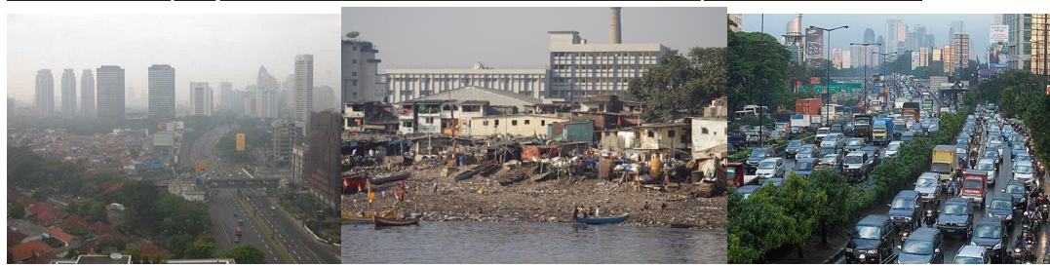

**Source B – Text outlining the causes and consequences of urbanisation in Jakarta**



*Refer to Source A, Source B and your own research to answer Question 1 parts (a) and (b)*

**Question 1**

1. Identify, with evidence, consequences of urbanisation in Jakarta?

………………………………………………………………………………………………………………………………………………………..

1. Outline ways that Indonesia has reduced the negative impacts of urbanisation in Jakarta since 2000. Justify your reasons with evidence.

………………………………………………………………………………………………………………………………………………………..

Suggested articles for research:

* *Governor Ahok’s Policy to Solve Jakarta’s Traffic Jams – NewCities*
* *Jakarta at 30 million: my city is choking and sinking – it needs a new Plan B – The Guardian*
* *Air pollution in Jakarta, an invisible health threat – The Jakarta Post*

**Question 2**

Recently, Indonesian President Joko Widodo decided to relocate the Indonesian Capital from Jakarta to Palangkaraya in Central Kalimantan.

* 1. Jakarta is situated on which Indonesian island? ………………………………………
  2. How would you classify Jakarta as an urban settlement? …………………………………………..
  3. What evidence can you find to support your answer?

………………………………………………………………………………………………………………………………………..………………………………Using your own research, how and why has Jakarta’s population changed over the last 50 years and predict how this will change into the future.

………………………………………………………………………………………………………………………………………..………………………………

**Question 3**

Recently, Indonesian President Joko Widodo decided to relocate the Indonesian Capital from Jakarta to Palangkaraya in Central Kalimantan.

**Source C – Aerial photo and Satellite Image of Palangkaraya in Central Kalimantan**

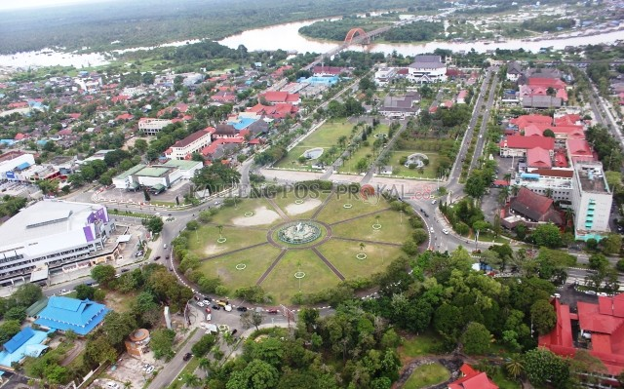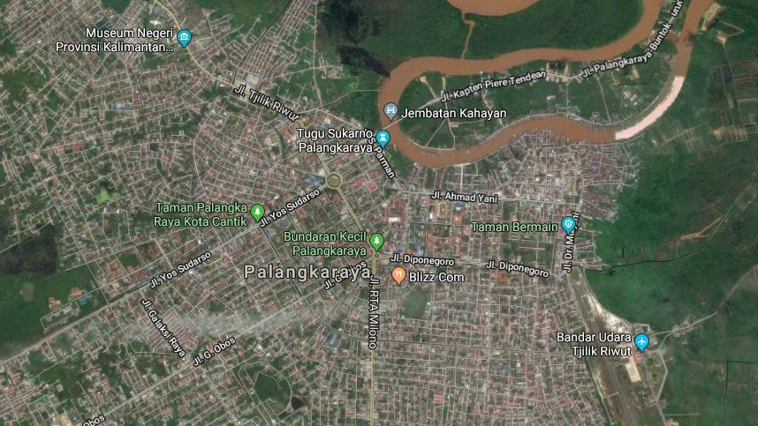

1. The suggested site, Palangkaraya in Central Kalimantan, is situated on what island? ……………………………….
2. With reference to Source C and Google Maps/Earth, describe how the land is used in and around Palangkaraya.

……………………………………………………………………………………………………………………………………

**Question 4:**

1. Plot the location of Palangkaraya on the map (Source D) below. Mark with an ‘X’.

**Source D – Map of Indonesia and surrounding countries**

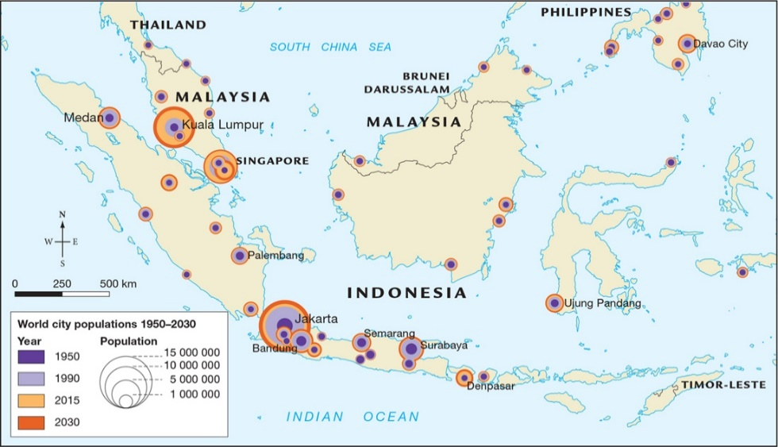

1. Using Source D (above), and online research contrast the population pyramid structure of Singapore with Indonesia.

Suggested sources for research:

* *populationpyramid.net*

……………………………………………………………………………………………………………………………………..…………………………………

1. Outline one Social, Economic, and Environmental consequence of the pyramid structure for either Singapore **OR** Indonesia (circle choice)

Social ……………………………………………………………………………………………………………………………………………………………….

Economic ………………………………………………………………………………………………………………………………………………………….

Environmental ……………………………………………………………………………………………………………………………………………………..

**Part 2 – EXTENDED RESPONSE.**

**Answer Question 5**

**Answer in the space provided.**

*Allow about 20 minutes for this section*

**___________________________________________________________**

**Criteria*:* Critical thinking and communication**

In your answer you will be assessed on your ability to:

|  |
| --- |
| * Discuss concepts * Synthesize information to make valid, well-supported arguments * Analyse sources and data for usefulness * Interpret different perspectives and implications * Communicate information and ideas effectively * Structure information and ideas in an appropriate format |

**Question 5**

|  |
| --- |
| At a press conference on Monday, President Joko Widodo will deliver a speech and decide whether to move the capital city to Palangkaraya or keep it in Jakarta.  He needs your help to research and write the speech. |

**Instructions:**

1. Using your answers to Questions 1-4, research, and your own knowledge, write a **speech**that addresses the following aspects:
2. What problems have been caused by urbanisation in Jakarta?
3. What are the main reasons for the move to Palangkaraya?
4. If you want to move the capital: explain what solutions will you recommend to make sure the problems in Jakarta are not repeated in Palangkaraya? Support your response with evidence.
5. If you do not want to move the capital: Explain what solutions will you recommend to ensure that the consequences of urbanisation in Jakarta are reduced? Support your response with evidence.

Mr Speaker, fellow Ministers, and staff, last Monday I announced that, due to the devastating consequences of urbanisation in Jakarta, we have to …………………………………………………………………………………………………………………………………………………………………….

**End of Examination**