Appendix 3: Student activities for The Amazon Burns

Created by Lorraine Chaffer for GTANSW & ACT

The Geography Bulletin 2019 Edition 4 (Volume 51 No 4)
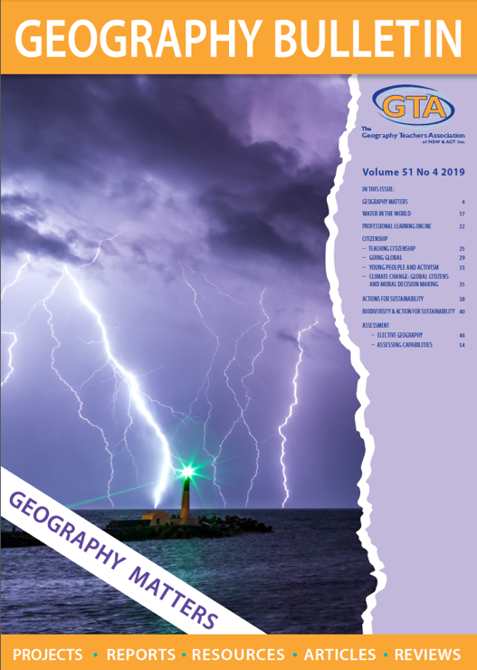

This document has been provided in both PDF and Word formats to allow teachers to add or delete elements as appropriate to their students.

Login to your account to access the GTA Bulletin and individual articles for printing where required.

Students will need a copy of the article ‘The Amazon Burns by Grant Kleeman, to complete the activity.

Further investigate the environmental change in the Amazon Rainforest using the following sites

Amazon sees alarming rise in deforestation
https://www.dw.com/en/amazon-sees-alarming-rise-in-deforestation/a-51668498

The Biotic Pump: How Forests Create Rain
https://www.youtube.com/watch?v=kKL40aBg-7E

THE AMAZON BURNS

What is? Where? Why there? Why care?
What is happening in the Amazon?

Why is it happening?
What is the Amazon?

Where is the Amazon?

Why is it there?

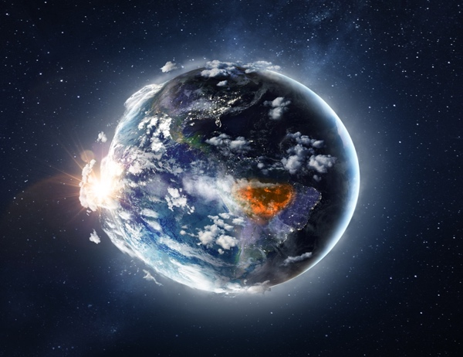
Why should we care about what is happening in the Amazon?

What can be done?

For each geographical concept write one sentence linking that concept to changes in the Amazon.

Place………………………………………………………………………………………………………………………………………………………………………………………………………………………………………………………………………………………………………………………………………
Space…………………………………………………………………………………………………………………………………………………………….………………………………………………………………………………………………………………………………………………………………………
Scale ……………………………………………………………………………………………………………………………………………………………..
……………………………………………………………………………………………………………………………………………………………………..
Environment ………………………………………………………………………………………………………………………………………………...
………………………………………………………………………………………………………………………………………………………………………
Change ………………………………………………………………………………………………………………………………………………………….
………………………………………………………………………………………………………………………………………………………………………
Interconnection…………………………………………………………………………………………………………………………………………….
………………………………………………………………………………………………………………………………………………………………………
Sustainability ………………………………………………………………………………………………………………………………………………..
………………………………………………………………………………………………………………………………………………………………………
Write a 100 word abstract that summarises the key message in this article?

