Appendix 4:

Student activities created by Lorraine Chaffer for GTANSW & ACT

The Geography Bulletin 2019 Edition 4 (Volume 51 No 4)

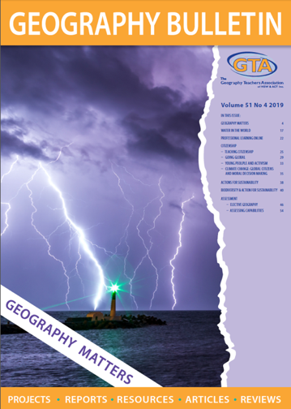

This document has been provided in both PDF and Word formats to allow teachers to add or delete elements as appropriate to their students.

Login to your account to access the GTA Bulletin and individual articles for printing where required.

Acknowledgement: Thank you Future Crunch for allowing GTANSW & ACT to use your material.

99 Good new stories you probably didn’t hear about in 2019
from

Future Crunch
https://futurecrun.ch/99-good-news-2019

99 GOOD NEW STORIES FROM 2019: INTRODUCTION
https://futurecrun.ch/99-good-news-2019

It didn’t look very good out there in 2019.
Countries on the verge of collapse, people taking to the streets, some in peaceful marches, others in extinction rebellions or violent clashes with security forces. Populism and bigotry rearing their ugly heads, prejudice worming its way into the algorithms, power corrupting absolutely, the powerless ignored or locked in cages on the border. Trade wars, surveillance capitalism and ‘re-education camps,’ war-torn hotspots mired in conflict, a global economy seemingly incapable of fixing its excesses, the rich getting richer, the political lies becoming more brazen. An entire species fouling its own nest, the emissions (still!) rising, wildfires burning and losses cascading across ecosystems.
Just like you, we watched the news. We submitted ourselves to this insane, 21st century global experiment: take a nervous system that's evolved for running away from cheetahs and give it a big glowing screen showing it all the bad things happening in the world in near real time.
That wasn’t the whole story though. We also spent the year collecting other kinds of news, stories of conservation, health, rising living standards, tolerance, peace, cleaner energy and environmental stewardship.
Unfortunately, that stuff didn’t make it into our collective news feeds and that means that what we saw on our screens in 2019 was not the world. It was a negative image of the world, in both the photographic and tonal senses.
So, here’s a better picture.
Activity
- In groups, brainstorm and list any GOOD NEWS you recall from 2019 that could be considered “geographical”.

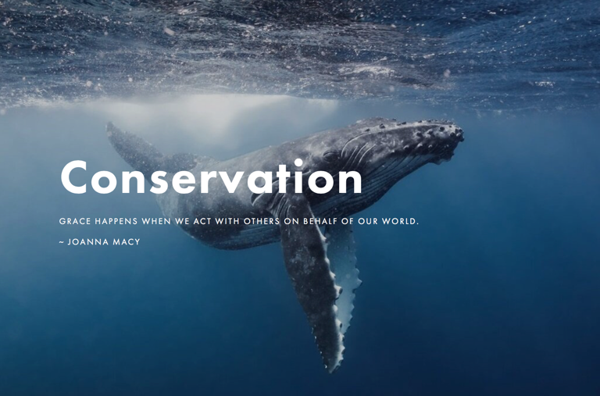
GOOD NEW STORIES FOR CONSERVATION

1. New surveys revealed that the population of humpback whales in the South Atlantic region now number 24,900 — almost 93% of their population size before they were hunted to the brink of extinction. BBC
2. Chinese authorities began preparations for the creation of the largest national park in the country’s history, covering an area of 27,134 km², and home to more than 1,200 wild giant pandas. NatGeo
3. The indigenous Waorani community of Ecuador won a landmark case against oil companies this year, protecting 180,000 hectares of their land against exploitation. Al Jazeera
4. In 2019, the United States passed a new law outlawing animal cruelty, China issued guidelines stating that from 2020 non-animal testing will be the preferred method for cosmetic products, and in Australia, cosmetics companies were banned from using data derived from animal testing.
5. Dolphins are breeding in the Potomac River in Washington for the first time since the 1880s, whale populations are exploding off the shores of New York, and 100 seal pups have been born on the shores of the Thames, 60 years after the river was declared 'biologically dead.' Telegraph
6. In July, Ethiopia smashed the world record for tree planting. Led by Prime Minister Abiy Ahmed, millions of Ethiopians planted 353 million trees in 12 hours. BBC

7. The city of Seoul shut down all its remaining dog butcheries this year, and the Netherlands became the first country in the world to eliminate all stray dogs – not by euthanasia, but through education, free veterinary care and re-homing. Amsterdam Hangout
8. In Kenya, poaching rates have dropped by 85% for rhinos and 78% for elephants in the last five years, in South Africa, the number of rhinos killed by poachers fell by 25%, the fifth annual decrease in a row, and in Mozambique, one of Africa’s largest wildlife reserves went an entire year without losing a single elephant.
9. Belize doubled the size of ocean reserves around the world’s second largest barrier reef, South Africa increased its proportion of protected waters from 0.4% to 5.4%, Argentina created two new marine parks in the South Atlantic, bringing total protected areas to 8%, and Canada became the first country in the world to protect more than 10% of its ocean waters, after the government partnered with Inuit custodians to create its largest marine reserve ever.
10. For the first time since 1870, herds of bison are roaming the Badlands National Park in South Dakota. 1,200 bison now have 80,000 acres to graze. WWF
11. India reported that its population of tigers has risen by over a third since 2014, and in Siberia, an unprecedented collaboration between China and Russia has paved the way for a new transnational park for the Amur leopard and the Siberian tiger.

12. Since 1990, France’s forest areas have increased by 7%, in Nepal, satellite images revealed that forests expanded from 26% in 1992 to 45% in 2016, and Costa Rica announced it has doubled its forest cover in the last 30 years; half its land surface is now covered with trees, a huge carbon sink and a big draw for tourists.
13. A new study revealed that the status of Great Britain's carnivores has “improved markedly since the 1960s.” Thanks to conservation efforts, otters, pine martens, badgers and polecats have staged remarkable recoveries. Wiley
14. Canada banned the trade, possession, capture and breeding of whales, dolphins and porpoises, passed a Fisheries Act containing a legally binding requirement to rebuild fish populations, and unveiled new standards for marine protected areas, banning all oil-and-gas activity as well as mining, dumping and bottom-trawling.
15. An unprecedented conservation effort returned the Mexican Grey Wolf from the brink of extinction, giving it a new home in a reserve with other species endemic to its former territories, such as prairie dogs, bison, and longhorn sheep. Mexico News Daily
16. China's tree stock rose by 4.56 billion m³ between 2005 and 2018, deserts are shrinking by 2,400 km² a year, and forests now account for 22% of land area. SCMP
17. The US Senate passed its most sweeping conservation legislation in a decade, protecting 1.3 million acres and withdrawing 370,000 acres from land available to mining companies. LA Times
Activity
Select ONE of the following stories – 1, 8, 10, 11, 12 (Nepal) or 14
Read the article and share your story with another student.
Use this scaffold to guide your conversation
- What is the story?
- Where did it happen?
- Why did it happen?
- Why is this good news?
Create an inquiry question you could use the further investigate this story.

GOOD NEW STORIES FOR GLOBAL HEALTH

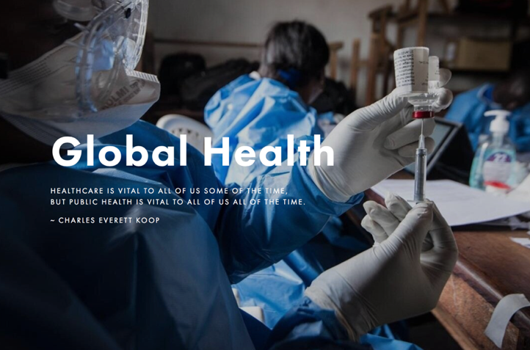

18. Algeria and Argentina officially eliminated malaria this year, and the WHO said that in the last eight years, malaria infections in Cambodia, China, Laos, Myanmar, Thailand and Vietnam dropped by 76%, and deaths fell by 95%. India also reported a huge reduction in malaria, with 2.6 million fewer cases in 2018 than in 2017. Nature
19. The Global Burden of Disease Report said that between 1990 and 2017, the number of kids and teenagers dying around the world decreased by more than half, from 13.77 million to 6.64 million. CNN
20. Remember bird flu, the disease that was going to be the next global pandemic? There hasn't been a single H5N1 human infection since February 2017. STAT
21. According to the United Nations, global HIV-related deaths have fallen to 770,000, a third lower than in 2010 when 1.2 million deaths were recorded. Deutsche Welle
22. Senegal became the first African country to begin providing free treatment for women with breast or cervical cancer (the leading cause of cancer deaths), and Mali announced it would begin providing free healthcare for pregnant women and children under five. Guardian
23. In the biggest breakthrough for cystic fibrosis in decades, a new drug that targets the genetic roots of the disease was approved by the FDA. Washington Post

24. The UN released its latest figures on pneumonia, showing that the number of children dying from "the ultimate disease of poverty," has decreased from 6,410 per day in 1990 to 2,216 per day in 2017. OWiD
25. The Philippines passed a Universal Health Care Act, entitling all of its 107 million citizens to health insurance and medical treatment, and Malaysia started providing free healthcare insurance for the country's poorest 40%, providing coverage against 36 critical illnesses.
26. The CDC announced that cigarette smoking among US adults has reached an all-time low of 13.7% (a decline of two-thirds in the last 50 years) and in the UK, the number of cigarettes being smoked fell by nearly a quarter between 2011 and 2018. Cancer UK ﻿
27. Russian officials reported that alcohol consumption has decreased by 43% since 2003. As a result average life expectancy in 2018 reached its highest level ever. BBC
28. The AIHW said that more people are surviving cancer in Australia than ever before. Since 1989, the mortality rate has dropped by 32% for men and by 21% for women.
29. Between 1990 and 2019, cancer mortality rates fell by 18% in Argentina, 26% in Chile, 14% in Colombia, 17% in Mexico and 13% in Venezuela, corresponding to almost half a million avoided deaths. International Journal of Cancer

30. Malawi eliminated the world’s most common infectious eye disease, trachoma, the second African country to do so after Ghana. In 2014 more than eight million people were at risk. Today, that number is zero. Hippocratic Post
31. A new vaccine for typhoid reduced cases by more than 80% in trials, and is now being used to immunise nine million children in Pakistan. BBC
32. Stroke rates for US adults over the age of 65 have decreased by one third each decade for the last 30 years, new diabetes cases have declined by 35% since 2009, the longest decline since the government started tracking the statistic, and under the Affordable Care Act nearly 2 million diabetics, have now received access to health insurance.
33. In Rwanda, 95% of babies currently receive vaccinations for rubella, measles and polio, and it's also on track to be the first country to eliminate cervical cancer. CNN
34. Heart disease rates in the UK are on the decline - it's still the leading cause of mortality, but deaths have decreased by almost half since 2005. Telegraph
35. Between 2000 and 2018, the global incidence of measles fell by two-thirds, and more than 23 million lives were saved by the measles vaccine. ACS
36. A new Ebola vaccine was cleared for distribution in 2019, and is working miracles, reducing mortality rates from 70% to as low as 6%. Boston University
37. The WHO revealed that the average decline in the incidence of tuberculosis, the leading infectious cause of death worldwide, has been 1.6% every year between 2000 and 2018, and in August, a new cure for a deadly strain of TB was approved, clearing the path for global distribution. NYT
38. Type 3 polio officially became the second species of poliovirus to be eliminated in 2019. Only Type 1 now remains - and only in Pakistan and Afghanistan. STAT
Activity
Explain the link between human health and the following Geography concepts
- Liveability
- Human Wellbeing
- Human rights

Discuss - Why is human health a Geography topic

GOOD NEW STORIES FOR LIVING STANDARDS

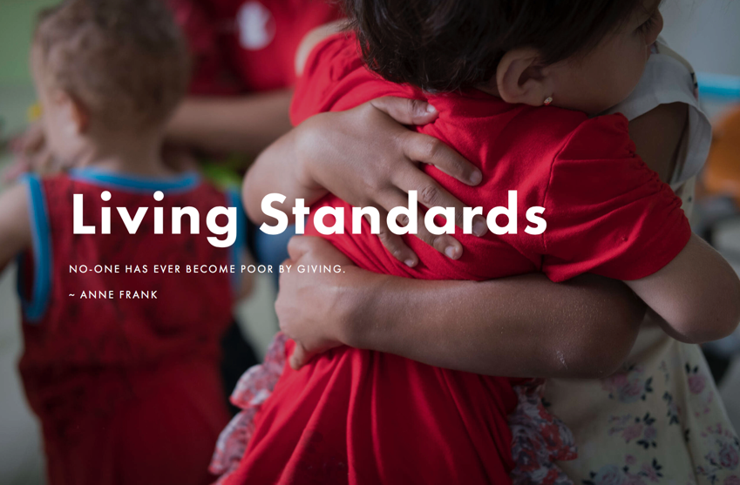

39. New research showed that the proportion of people in extreme poverty around the world fell from 36% in 1990 to 8.6% in 2018. Absolute numbers were down from 1.9 billion in 1990 to 610 million in 2018. ODI
40. The biggest global story you didn’t hear about this year was the successful conclusion of India's extraordinary sanitation drive. In the last five years, 90 million toilets have been built, 93% of households now have access, and 500 million people have stopped defecating in the open. Economic Times
41. The second biggest story was in Save the Children’s 2019 Global Childhood Report showing that in the last 20 years, children's lives have improved in 173 out of 176 countries. Compared to 2000, today there are:
- 4.4 million fewer child deaths per year
- 49 million fewer stunted children
- 130 million more children in school
- 94 million fewer child labourers
- 11 million fewer girls forced into marriage or married early
- 3 million fewer teen births per year
- 12,000 fewer child homicides per year
Naturally this was front page news everywhere.
42. China now has equal numbers of girls and boys in primary and high school, and more than half of university students are women, up from less than a quarter in 1978. Xinhua

43. 30,000 children in Cambodia have been rescued from hard labour in the past five years, and 180,000 prevented from being child workers. Phnom Penh Post
44. According to the World Bank, India halved its poverty rate in the past 30 years, increased life expectancy at birth by 11.6 years, increased the average number of schooling years by 3.5 years, and increased per capita incomes by a factor of 250.
45. Western liberal democracies are not suffering from a loneliness epidemic. Adolescents in the United States are not more likely to report feeling lonely than adolescents from a couple of decades ago; older adults do not report higher loneliness than older adults in the past, and surveys covering Germany, England and Sweden point in the same direction. OWiD
46. Since the beginning of the century, the number of houses with adequate sanitation, living area and reliable construction doubled in sub-Saharan Africa, from 11% to 23%. Nature
48. Officials in Nepal reported that 8.8 million people have gained access to electricity since 2010, and that the country is on track for universal access by 2022. Kathmandu Post

47. Nepal was also declared an open defecation free country in 2019. Eight years ago, nine million people did not have access to clean sanitation facilities. Rising Nepal
49. Poverty in the United States reached its lowest rate since 2007, with 1.4 million people leaving poverty in a single year, and poverty in Canada reached the lowest level ever recorded, 9.5%, down from 15.6% in 2006.
50. UNESCO said that 19 African countries reached gender parity (equal numbers of boys and girls) in primary education in the past decade. Brookings
51. A new report on the social performance of 149 countries in the last five years, using indicators like nutrition, shelter, safety, education, health, rights and inclusiveness, said that only four countries have regressed overall since 2014. First Post
Activity
Map (Digital or hard copy) six countries referred to in the Living Standards stories.
Identify FOUR concepts that appear in these stories e.g. sanitation
*These two activities could be used to create a digital Story Map
Create FRAYER diagrams to show your understanding of these concepts
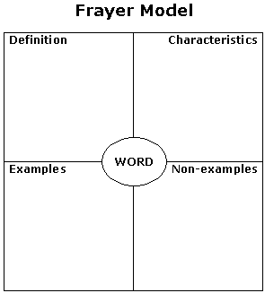

http://www.readingeducator.org/strategies/frayer.htm
GOOD NEW STORIES FOR PEACE, SAFETY and HUMAN RIGHTS
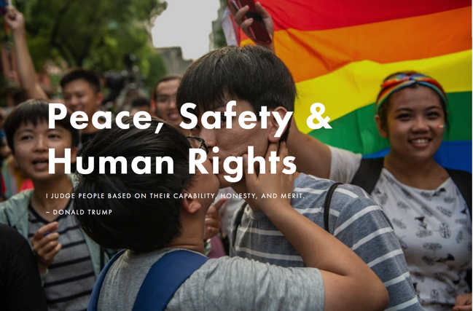

52. Democracy is proving far more resilient than the headlines suggest. Since 2000, the number of democracies has risen from 90 to 97, including 11 countries that became democratic for the first time ever, and in 2019, 2 billion people in 50 countries voted, the largest number in history. Al Jazeera
53. A new survey across 167 countries said that tolerance towards LGBTQIA+ people has risen in almost every region of the world in the last decade. Japan Times
54. The number of people killed in wars around the world reached its lowest level in seven years, and battle fatalities have fallen by 43% since 2014. PRIO
55. Indonesia lifted the minimum legal age for marriage from 16 to 19, Mozambique made child marriage punishable by 12 years in prison, Mexico banned it in 31 out of 32 states, and a new UN report said that in South Asia the practice has almost halved in the past 25 years, falling from 59% per cent to 30% today.
56. Taiwan became the first Asian country to legalize same sex marriage. “#LoveWon,” President Tsai Ing-wen tweeted after the vote, “We took a big step towards true equality, and made Taiwan a better country.” NYT
57. The number of people incarcerated in American prisons declined again, to 1.48 million people (down from 1.61 million in 2009) and California banned the operation of private prisons – finally removing the profit motive from incarceration. Guardian
58. The 2019 Global Terrorism Index revealed that deaths from terrorism decreased by 15.2% last year, the fourth consecutive year of improvement. The overall number of terror attacks fell by a third, deaths halved, and attacks by Daesh fell by 71%.

59. This year Saudi Arabia granted women the right to travel overseas, register births, marriage & divorce, receive family documents be eligible as guardians to minors, and congregate in the same places as men. Reuters
60. A new study covering 90% of the world's population showed that the international homicide rate has dropped by 20% since 1990. Eureka Alert
61. In 2019, Northern Ireland officially legalised the right of women to decide what to do with their own bodies, and the right of people to love and marry anyone they choose. Human Rights Watch
62. Five countries – France, Kosovo, South Africa, Georgia and Scotland - banned corporal punishment, bringing the total number to 58. End Corporal Punishment
63. The World Health Organisation removed 'gender identity disorder' from its list of mental illnesses. CBS
64. The biggest ever US survey of attitudes towards sexuality, race, skin tone, age, disability and body weight showed that Americans have become more tolerant since 2007. Decreases in bias ranged from 49% for sexuality, to 17% for race and 15% for body weight. Scientific American
65. Sudan's dictatorship was overthrown after months of protests this year, its leaders signed a landmark deal for transition to civilian government and also repealed a series of laws used to regulate women’s behaviour under the former president. Guardian
66. India and Pakistan opened a peace corridor on their border, allowing Sikhs to visit their second holiest site, the shrines dedicated to Guru Nanak, for the first time in 72 years. Al Jazeera

67. Global executions fell by almost a third last year, reaching their lowest figure in at least a decade. Amnesty International
68. German labour officials said that refugees were integrating into the job market far quicker than expected. Around 400,000 people of working age are now employed. The Local
69. In June, Kenya's High Court ruled that rape survivors have the right to an abortion, a landmark ruling in a country where women still do not have the right to choose. Reuters
70. Abortion became legal in every state in Australia, Oaxaca became become the second state in Mexico to give women autonomy over their own bodies and in the United States, abortion rates reached their lowest level since Roe vs. Wade in 1973. CNN
71. Research from UCLA showed that an estimated 10,000 LGBTQIA+ teens in the US have been protected from conversion therapy in states that have banned the practice since 2012. NBC
72. In a landmark victory for Africa's human rights activists, Botswana decriminalized homosexuality, overturning a colonial-era law, and Angola decriminalised same-sex conduct, overturning the penal code it also inherited from colonisation.
73. India's parliament approved a bill that criminalises the practice of triple talaq which allows a husband to divorce his wife by repeating the word "talaq" three times. BBC
74. The FBI said that the United States’ violent crime rate fell again last year, and is now half as high as it was in 1991. Young people are now six times less likely to be victims of violent crime than they were in the mid 1990s, and property crime rates continued to decline too. Marshall Project
75. A majority in Brazil's Supreme Court voted in favour of criminalising homophobia and transphobia in 2019. BBC
Activity
Identify different groups of people in society impacted by the changes in these stories

GOOD NEW STORIES FOR ENERGY and SUSTAINABILITY

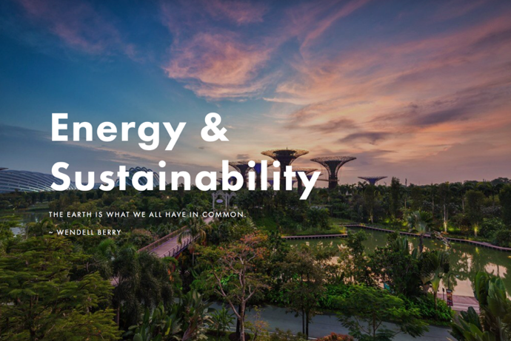

76. The world’s largest multilateral financial institution, The European Investment Bank, agreed to stop all financing for fossil fuels, and committed to investing half of its entire annual outlay — not just its energy budget — on climate action and sustainability by 2025. Guardian
77. The US Environmental Protection Agency banned 12 products containing neonicotinoids, a pesticide that is dangerous for bees, and California, the US’s most productive agricultural state, said it would no longer a widely used pesticide blamed for harming brain development in babies. Associated Press
78. Four years after it won the dubious title of the world’s dirtiest city, air pollution in Delhi has dropped by 25%. In Beijing, air pollutants fell to their lowest level ever recorded, in Madrid a ban on vehicles in the city centre reduced levels of nitric oxide by 38%, and in London pollution fell by a third inside a new low emissions zone that was launched at the beginning of the year.
79. Electricity generation from coal power stations fell by around 3% this year, the largest drop on record, and 42% per cent of the world’s coal fleet is now losing money. BBC
80. The European Union experienced an unprecedented 19% year-on-year decline in coal-fired power generation in the first half of 2019, and this will accelerate in the second half of the year to an estimated 23% fall in 2019. Carbon Brief
81. Coal had a particularly bad year in the United States. Shipments fell to their lowest level since 1983, and eight companies went bankrupt, including Murray Energy, the country’s largest private coal company. #MAGA. Bloomberg
82. The good news? Clean energy jobs grew by 3.6% in the United States last year, adding 110,000 net new jobs, and the dramatic reduction of coal in the country's energy mix has reduced deaths from air pollution and has cut the cost of damages by more than $200 billion. Ars Technica

83. Ten of the world’s top 35 insurance companies withdrew their cover for coal projects in 2019, bringing the global total to 17, and leaving only Lloyd’s of London and Asian insurers as the ‘last resort’ for fossil fuels. Guardian
84. The world's largest car supplier, Bosch, said it will be fully carbon neutral by 2020, making it the first major industrial company to take that step. Reuters
85. The largest retail company in the world announced this year that it will run entirely on renewable energy by 2030 and will be fully carbon neutral by 2040. The Verge
86. Repsol, Spain's largest oil and gas company, wrote down $5 billion in assets and became the world's first major oil producer to commit to complete decarbonization, BP wrote down $2.6 billion, and Chevron, the second-largest US oil company, wrote down the value of its assets by more than $10 billion, the largest energy-industry writedown in years. WSJ
87. Lazard, the industry’s benchmark, says that the cost of new wind and solar in 2019 dropped below the cost of keeping many of the world’s existing coal and nuclear power plants running. As Ramez Naam says, this year was well and truly the point at which we entered the next phase of the energy revolution. The question now is no longer “is it cheaper?” The question from here on is “how fast can we deploy?”
88. New Zealand passed a bill to reach zero carbon by 2050, committed to planting a billion trees in the next decade, and said it would run its grid entirely from clean energy by 2035. Independent

89. Chile reached its 2025 clean energy targets six years ahead of schedule, and along with eight other Latin American countries set a collective target of 70% renewable energy use by 2030, more than double what the European Union is currently planning. Reuters
90. The world’s sixth largest economy, the United Kingdom, generated more electricity from wind, sun, water and biomass in the third quarter of the year than from coal, oil and gas. Carbon Brief
91. The world’s fifth largest economy, California, reached its 33% clean energy target two years ahead of schedule, and fuel sales for cars are officially decreasing.
92. The world’s fourth largest economy, Germany, generated more electricity from wind, sun, water and biomass in the first six months of 2019 than from coal and nuclear. DW
93. The world’s second largest economy, the United States, generated more electricity from wind, sun and water in April than from coal for the first time ever. The Verge
94. Bloomberg NEF reported that the average price for battery packs fell to $156/kWh in 2019, an 87% drop compared to 2010, so it should come as no surprise that this was also the year…

95. that automakers finally put money on the table, collectively committing $225 billion for electric vehicles in the next five years. Volkswagen, the largest car manufacturer in the world, led the way, with a $44 billion ‘electric offensive’ and a promise to abandon the development of all new fossil fuel vehicles by 2026. NYT

96. It looks like the world may soon hit peak beef. The compound annual growth rate over the past decade was just 0.11%, production in Europe is now 26% below its peak level in 1991 and in Canada and Argentina beef production has fallen 41% and 16% from the mid-2000s. Bloomberg
97. In March, the European Union announced that plastic cutlery, plates, straws, cotton buds, balloons, food containers and polystyrene cups would no longer be allowed by 2021, and the Indian state of Tamil Nadu, home to 80 million people, imposed a full ban on all single use plastic.
98. In June, Canada followed in the EU’s footsteps, announcing a similar phase out of plastic by 2021, Tanzania implemented a plastic ban, Costa Rica signed a new law bringing an end to all styrofoam containers and packaging, Bali’s plastic ban went into effect and Panama became the first Central American nation to ban plastic bags.
99. And finishing off 2019 in style, Thailand announced in November that it would phase out microbeads, cap seals and oxo-degradable plastics by the end of the year, and will ban all plastic bags, cups, straws and styrofoam by 2022. Xinhua

Activities

Discuss how you could categorise the stories in this section eg clean energy
Record your categories here

Choose a colour for each category and mind map the stories in the space below – using the appropriate colour code in the space below.

Select ONE category to create an infographic.
You may need to do some further research to find images or graphs to add to your infographic.

Share your infographic to the class. Include
- a short explanation of the topic you selected
- an explanation as to “What makes this geography?”

